DA ASSIGNMENT 2
- Donut Chart
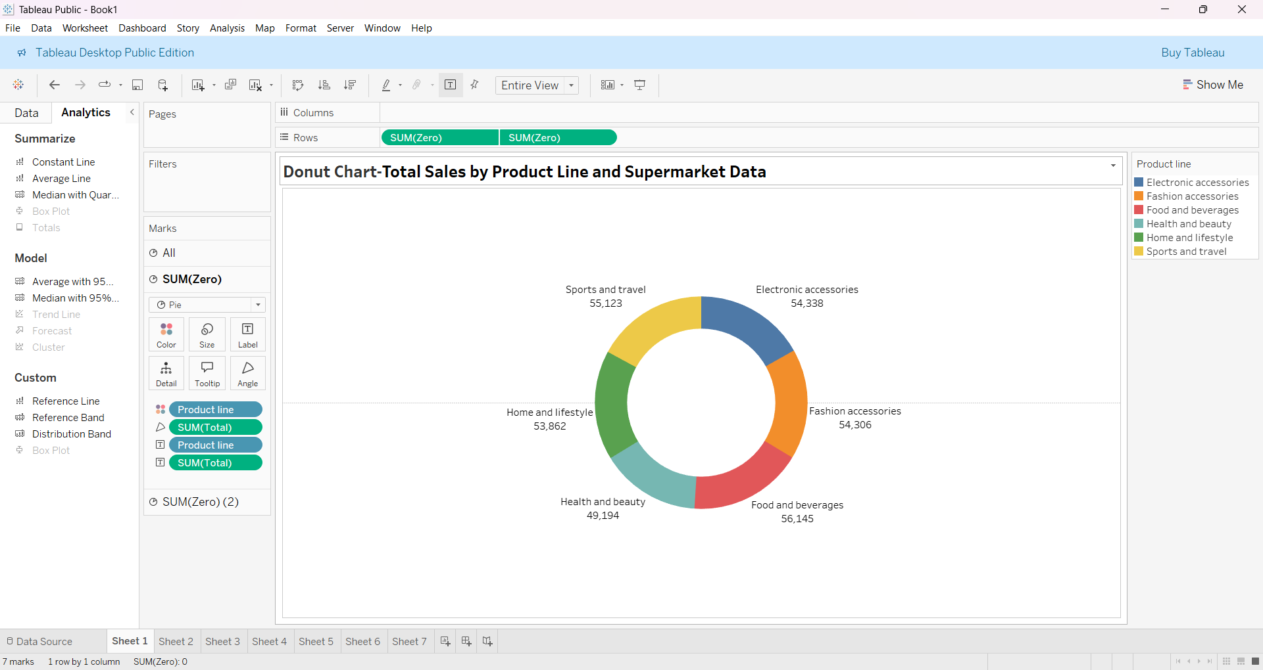

- Area Chart
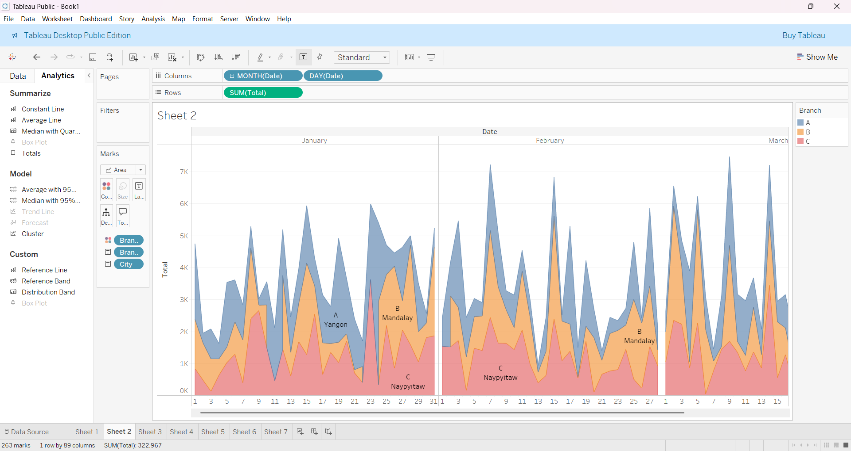

- Text Table
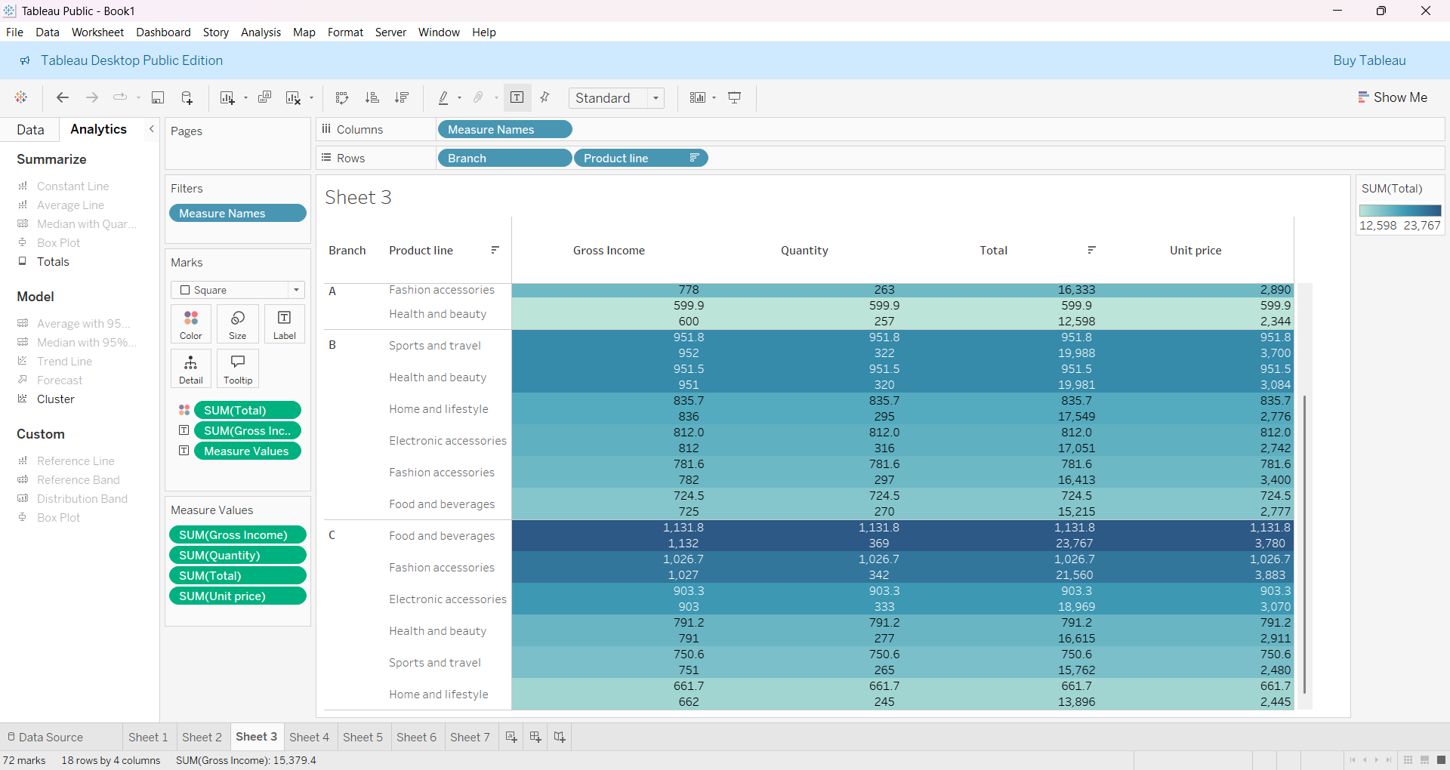

- Highlighted Table
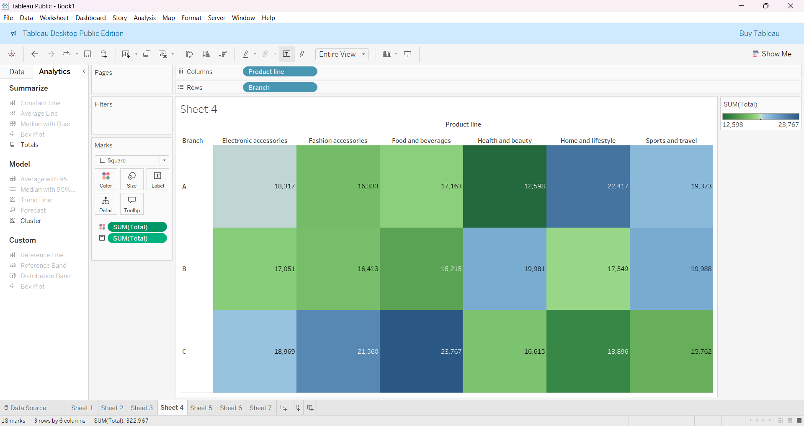

- Word Cloud
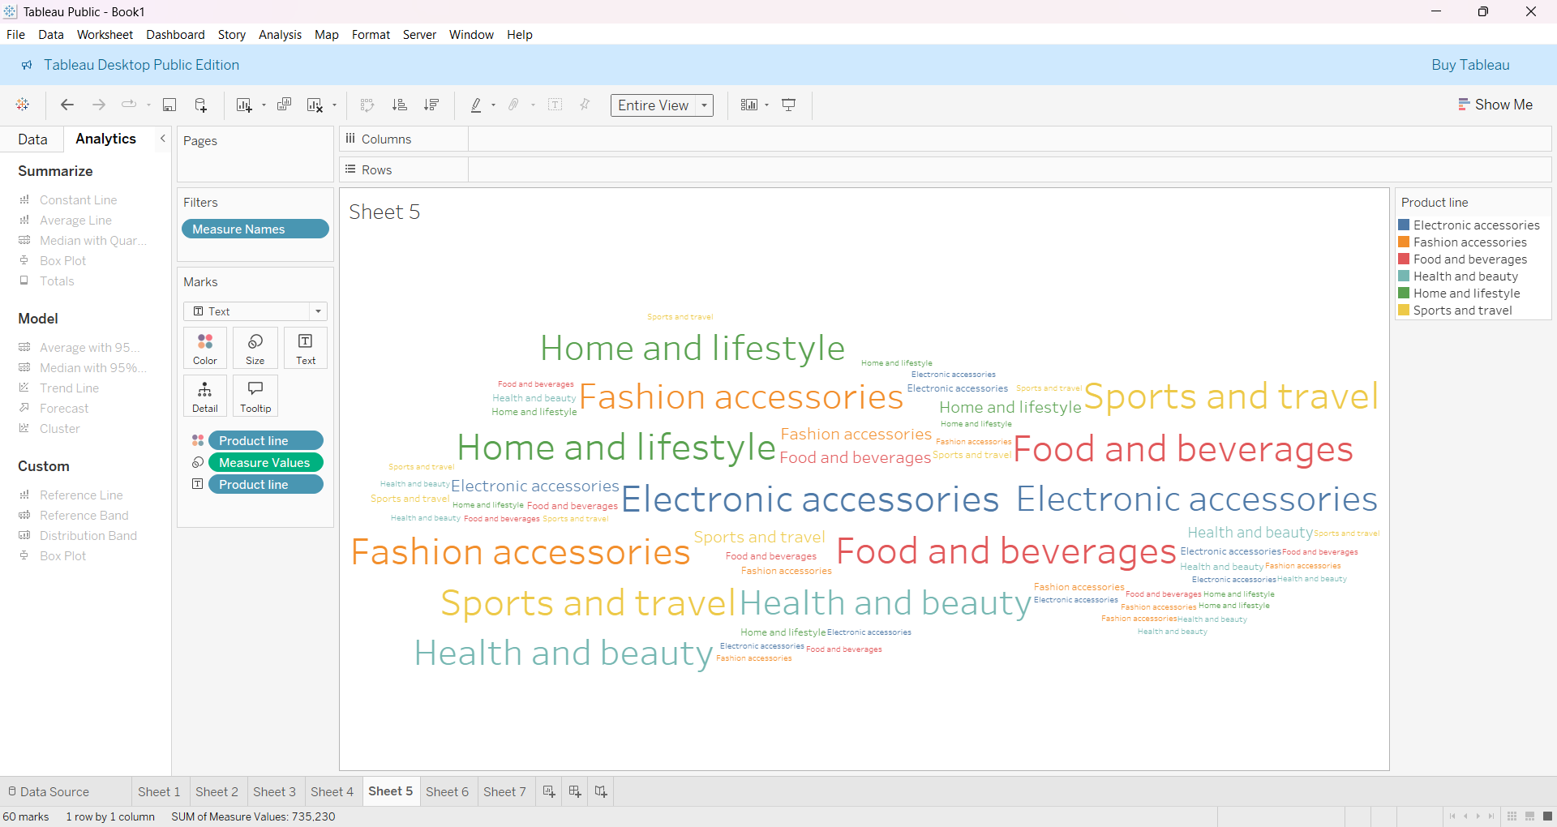

- Funnel Chart
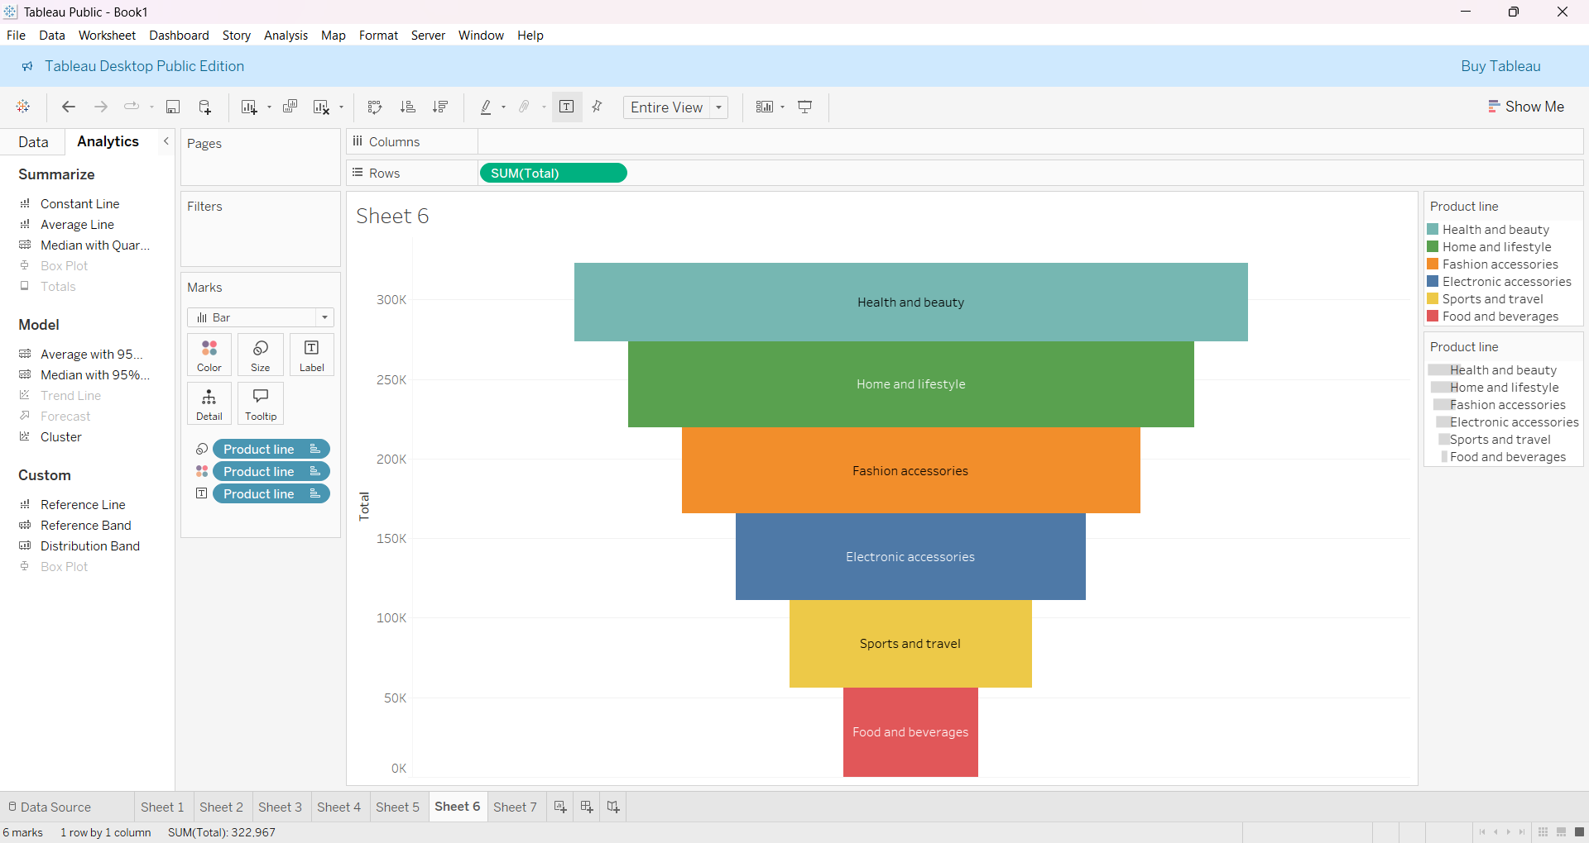

- Waterfall Chart
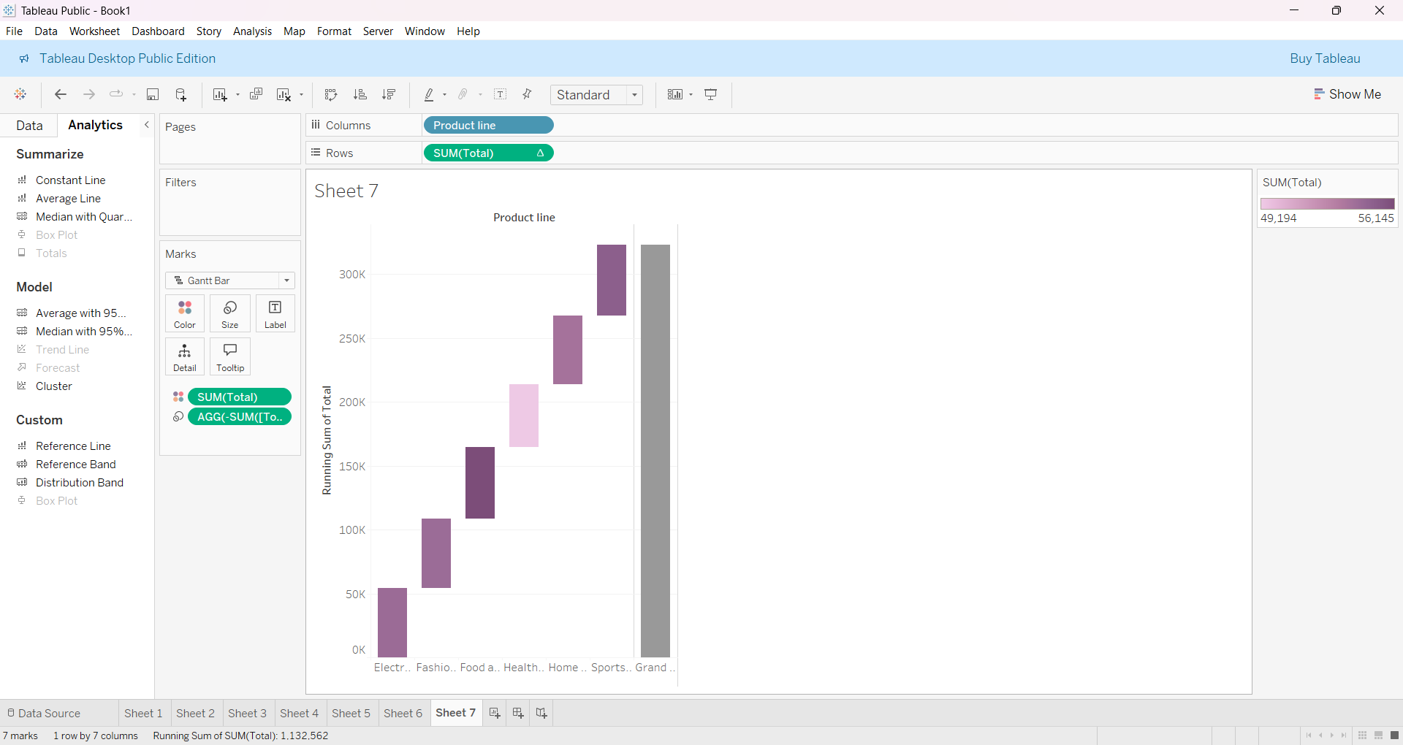

Submitted by:
NALLAPU UMAMAHESWAR REDDY
22BFA04475.

